# The General Form of a Quadratic Function

**The general form of a** **quadratic function** is written as

$$f\left(x\right)=ax^{2}+bx+c$$

where $a$, $b$, and $c$ are real numbers and $a≠0$. This polynomial has degree 2. The graph of this equation is called a parabola.

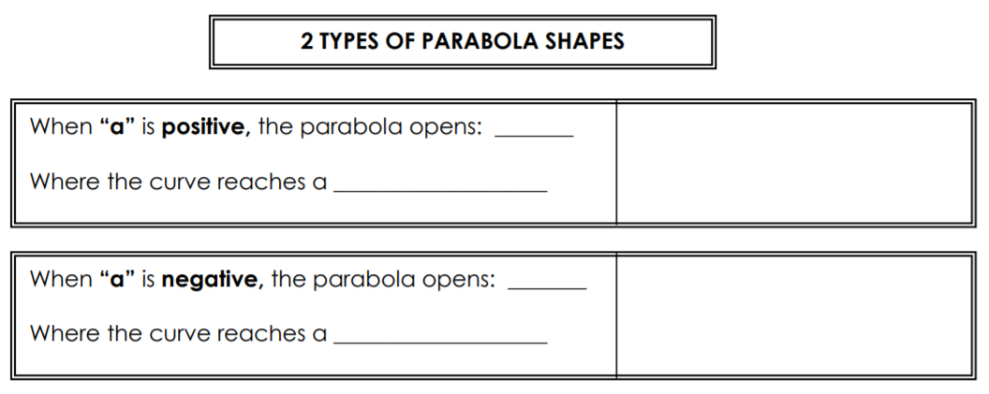

# Characteristics of Quadratic Functions

One characteristic of a parabola is how it opens. However, there are many more features that make a parabola unique.

These are some of the main characteristics of parabolas: 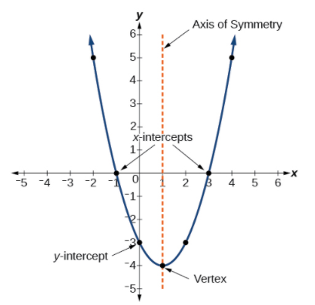

**Turning Point**: another term for the **vertex (maximum/minimum)** of a parabola. The vertex has coordinates $(x, y)$.

**Axis of Symmetry**: A line of symmetry that goes through the vertex of the parabola and is defined by $x=-\frac{b}{2a}$. The axis of symmetry is always a VERTICAL LINE ($x = \#$).

$x$**-intercept(s):** Where the graph crosses the $x$-axis.

$y$**-intercept(s):** Where the graph crosses the $y$-axis.

**Zeros (roots)** of a quadratic function are the points where the parabola intersects the $x$-axis. (i.e. $x-$ intercepts of a graph). You should be able to see visually how many roots there are and what they are:

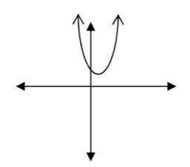

Zero real roots

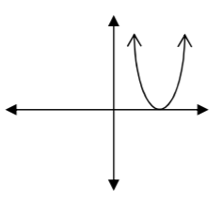

One real root

Two real roots

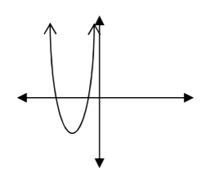

Examples:

1. 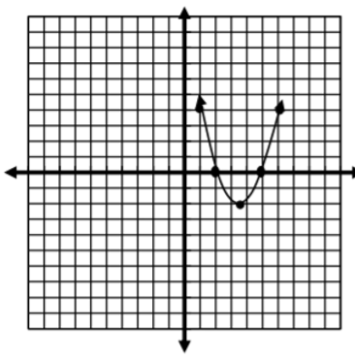 What is the axis of symmetry?
2. Is the vertex a minimum or a maximum?
3. How many zeros are there?
4. What are the $x-$ intercepts?

2) Use your calculator to graph the following function on the coordinate plane below and answer the questions.

$$f\left(x\right)=-x^{2}-2x+8$$

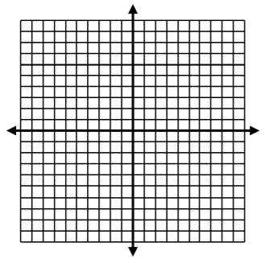

1. What are the coordinates of the vertex?
2. What is the axis of symmetry?
3. Is the turning point a minimum or a maximum?
4. How many zeros are there?
5. What are the $x-$ intercepts?
6. What are the domain and range of the function?

3) Determine whether $f\left(x\right)=-2x^{2}-8x+6$ has a minimum or maximum value and find the value of the minimum or maximum. Then, find the axis of symmetry.

# The Standard Form of a Quadratic Function

**The standard form of a quadratic function** is written as

$$f\left(x\right)=a{(x-h)}^{2}+k$$

where $(h, k)$ is the vertex. The vertex $\left(h, k\right)$ is located at

$$h=-\frac{b}{2a}, k=f\left(h\right)=f\left(\frac{-b}{2a}\right)$$

Because the vertex appears in the standard form of the quadratic function, this form is also known as the **vertex form of a quadratic function**.

Examples:

1. Determine whether $f\left(x\right)=3{(x-2)}^{2}-4$ has a minimum or maximum value and find the value of the minimum or maximum. Then, find the axis of symmetry.
2. Given the graph below, write the equation of the quadratic function in standard form.

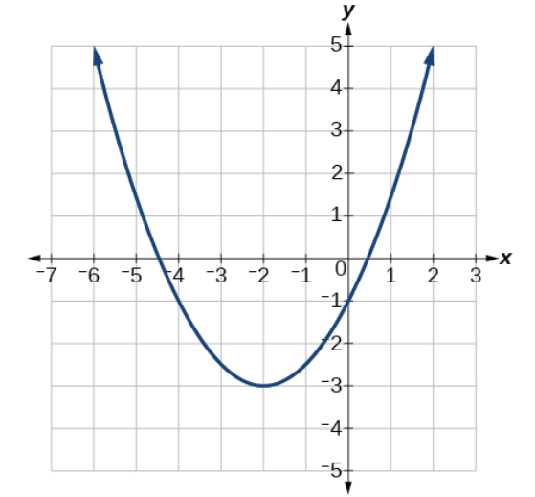

Since we will be using both of these forms, we should be able to transform one form into another.

Examples:

1. Transform the function $f\left(x\right)=-2{(x+5)}^{2}-3$ to general form.

To convert from general form to standard form, we must complete the square, making sure to keep the equation balanced. This will also help us determine characteristics of the quadratic, such as the vertex.

1. Find the vertex of the quadratic function $f\left(x\right)=2x^{2}-6x+7$. Rewrite the quadratic in standard form (vertex form).

# Applications

There are many real-world scenarios that involve finding the maximum or minimum value of a quadratic function, such as applications involving area and revenue.

Examples:

1) A motorcycle stunt rider jumped across Snake River. The path of his motorcycle was given approximately by $H=-0.005x^{2}+2.39x+600$ where $H$ was measured in feet above the river and $x$ was the distance from his launch ramp.

a) What was the rider’s maximum height above the river?

b) How far (horizontal distance) was the rider from the ramp when he reached his maximum height?

c) How high above the river was the launch ramp?

2) A backyard farmer wants to enclose a rectangular space for a new garden within her fenced backyard. She has purchased 80 feet of wire fencing to enclose three sides, and she will use a section of the backyard fence as the fourth side.

a) Find a formula for the area enclosed by the fence if the sides of fencing perpendicular to the existing fence have length $L$.

b) What dimensions should she make her garden to maximize the enclosed area?